Monday 8th November 2021
Christmas Wonderland

Dear Parents/Carers,

Friday 10th December is our Christmas Wonderland annual event for the whole school!

Children are invited to take part in the following activities on site during normal school hours:

- Visit with Santa
- Meet Santa’s reindeers
- Fair ground rides
- Ice Skating
- Snow Globe
- Ice Cream
- Christmas craft classroom activities
- Christmas Games for prizes

Some of these activities will be taking place outside and therefore it is important that your child has a warm coat, gloves scarf and a hat on this day.

The cost of the day will be fully funded by the school once again this year as we share the difficulties and pressures which all of our families continue to face as we emerge from the Covid 19 pandemic. It is our intention to ensure, to the best of our abilities, that all the children of Pike Fold Primary School end the term with the most magical Christmas experience possible!

On Christmas Wonderland day we will also be providing a special ‘Santa Box’ for lunch!

The box includes a sandwich, fruit, biscuit, crisps chocolate and drink as in the picture below.

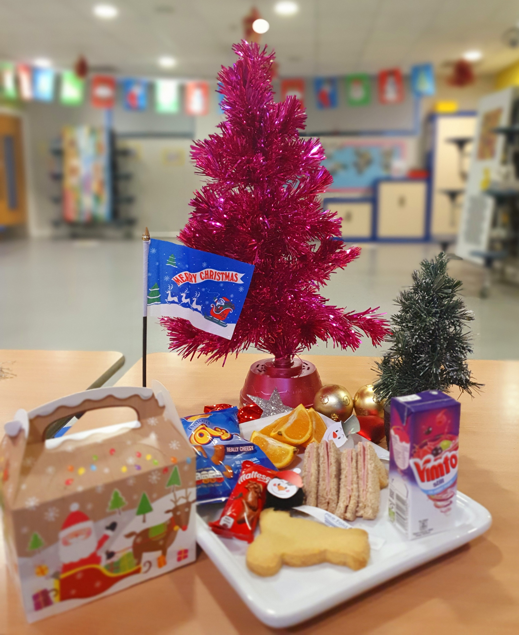

You will need to order this meal online via Aspens Select before 9am on Friday 10th December.

The ‘Santa Box’ is the only meal available to all children on Fridy 10th December.
All children who have a meal recorded in Aspens on this day WILL receive a Santa Box. Children who have not booked a meal will be required to bring a packed lunch.

If you have any questions at all please don’t hesitate to contact us.

Thank you for your ongoing support.

Yours Sincerely

K Nickson
School Business Manager

