Pike Fold Primary School ***‘Golden Threads’.***

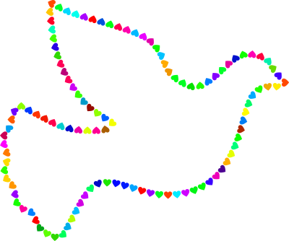

***P.E.A.C.E***

At **P**ike Fold Primary school, we come together as one family. We work together collaboratively, support each other, and actively encourage parents to be a part of their children’s learning both in school and at home. We recognise the need to ensure all children at Pike Fold have an awareness of diversity and culture and strive to celebrate this with each other. We ensure that children taking on their learning journey through Pike Fold leave with the skills and knowledge to become citizens in the future. As an inclusive school, we have high aspirations for all our children and provide a range of opportunities and experiences. Our curriculum, underpinned by the National Curriculum, is carefully sequenced and progressive, giving time to ensure children know more and remember more. We have a focus on providing our children, of all abilities and backgrounds, the chance to apply their new learning and take risks to solve challenging problems in all subjects.

**E**quality: At Pike Fold we believe happiness is the key to a positive and successful education, as well as encouraging kind and good moral character. It is important to us that all our children are immersed in experiences that are inclusive, meaningful, challenging, and engaging. Experiences can be seen in many different ways such as school trips, assemblies, visitors, resources, and experiences within lessons. In this thread, we develop a culture of inclusion for all where everyone feels proud of their identify and is able to participate fully in school life. Children address prejudice and bullying and support others to reach their potential. Pupils are provided with the opportunity to experience, understand and celebrate diversity. Our pupil premium ensures all children have access to a range of experiences and high-quality education, therefore no child is disadvantaged.

**A**cceptance: We promote understanding and acceptance between our communities. Developing a positive sense of community membership at all levels which leads to both support and responsibility. We encouraging all children and families to feel part of the wider community. Pike Fold takes time to understand the needs and hopes of all our communities and individuals. We ensure opportunities are provided within our curriculum to promote acceptance of all, and help pupils to value differences and to challenge prejudice, discrimination and stereotyping. The culture and ethos of our school is that, whatever the heritage and beliefs of children and families of the school community, everyone is welcome, equally valued and treat one another with respect.

**C**ommunity **E**ducation: Children learn about enterprise and develop their sense of community. Our enterprise projects encourage ambition and aspiration through the development of children’s enterprise skills. We encourage a range of people/parents to visit the school with different specialities so that children can see the different role models and aspire to different careers. We aim to give our children a sense of moral purpose that is linked to where they live. Some families within our community, suffer from economic and social disadvantages and often need a helping hand. School is an active part of the community. Through providing an education for all, by acknowledging the ethnic diversity, culture and faith of our pupils and families, we can enable future generations to enrich the society within which they live and work. ***The school community*** – our children, parents, carers and families, the staff and governing body. ***The community in which the school is located*** – Pike Fold in its ‘geographical community’ and the people who live and work in this area, not just the immediate neighbourhood but also the wider town/city. ***The United Kingdom community*** – Pike Fold, are by definition a part of this community. We engage with parents through curriculum evenings, teaching and learning activities, parent and child courses, and family liaison work, tailored to suit the needs and requirements of the school and parents. We work with local organisations and charities to offer support to targeted pupils, their families or for more general support

Pike Fold aims to achieve community understanding and engagement by promoting engagement between communities. Developing a positive sense of community membership at all levels, leads to both support and responsibility. We encouraging all children and families to feel part of the wider community. Pike Fold takes time to understand the needs and hopes of all our communities and individuals. We ensure opportunities are provided within our curriculum to promote shared values and help pupils to value differences and to challenge prejudice, discrimination and stereotyping. Pike Fold has curriculum-based activities whereby pupils’ understanding of community and diversity is enriched through visits e.g. to places of worship, and meetings and visits from members of the communities. We work together with community representatives e.g. visitors leading assemblies and have links with community groups and organisations, enabling them to play a role in the school and encouraging pupils to make a positive contribution in the local area. Our curriculum is implemented over 3 terms. Each term building on the knowledge and skills of exploration, creation and investigation regarding the world around us, locally, nationally and globally, where possible sequencing events from past to present. Each term linking with our communication and language development, *Colourful Semantics* which is embedding throughout school from N-Y6

|  |  |
| --- | --- |
| **Whole School termly focus** | |
| **Autumn** | Me and My world! *Let’s explore the world around me !* |
| **Spring** | What, Where, When? *What is it, where is it and when did that happen?* |
| **Summer** | When, How, Why? *When was that, how is that so and why do that?* |

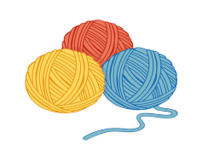**Curriculum Threads** Alongside our ‘Golden’ curriculum threads which embeds EQUALITY, ACCEPTANCE & COMMUNITY EDUCATION throughout our Whole School curriculum. We also have our ‘Termly focus’ threads-Autumn- Me and My World, Spring-What, Where & When? Our Summer term- When, How and why? Our subject thematic threads showing progression of skills and knowledge and creating a link between subjects.