Long Term Forecast EYFS Working towards NC Science
Three and Four-Year-Olds | Communication and Language |  | - Understand ‘why’ questions, like: “Why do you think the caterpillar got so fat?”
 | Personal, Social and Emotional Development |  | - Make healthy choices about food, drink, activity and toothbrushing.
 | Understanding the World |  | - Use all their senses in hands-on exploration of natural materials.  - Explore collections of materials with similar and/or different properties.  - Talk about what they see, using a wide vocabulary.  - Begin to make sense of their own life-story and family’s history.  - Explore how things work.  - Plant seeds and care for growing plants.  - Understand the key features of the life cycle of a plant and an animal.  - Begin to understand the need to respect and care for the natural environment and all living things.  - Explore and talk about different forces they can feel.  - Talk about the differences between materials and changes they notice.
Reception | Communication and Language |  | - Learn new vocabulary.  - Ask questions to find out more and to check what has been said to them.  - Articulate their ideas and thoughts in well-formed sentences.  - Describe events in some detail.  - Use talk to help work out problems and organise thinking and activities, and to explain how things work and why they might happen.  - Use new vocabulary in different contexts.
 | Personal, Social and Emotional Development |  | - Know and talk about the different factors that support their overall health and wellbeing:  - regular physical activity  - healthy eating  - toothbrushing  - sensible amounts of ‘screen time’  - having a good sleep routine  - being a safe pedestrian
 | Understanding the World |  | - Explore the natural world around them.  - Describe what they see, hear and feel while they are outside.  - Recognise some environments that are different to the one in which they live.  - Understand the effect of changing seasons on the natural world around them.
ELG | Communication and Language | Listening, Attention and Understanding | - Make comments about what they have heard and ask questions to clarify their understanding.
 | Personal, Social and Emotional Development | Managing Self | - Manage their own basic hygiene and personal needs, including dressing, going to the toilet and understanding the importance of healthy food choices.
 | Understanding the World | The Natural World | - Explore the natural world around them, making observations and drawing pictures of animals and plants.  - Know some similarities and differences between the natural world around them and contrasting environments, drawing on their experiences and what has been read in class.  - Understand some important processes and changes in the natural world around them, including the seasons and changing states of matter.
 | Cycle 1 |  | - All about Me  - Light and Dark | - Cold Places and Weather  - Food and Growth | - Minibeasts  - Pirates
 | Cycle 2 |  | - People who help us/Super-heroes  - Space | - Dinosaurs  - Farm | - Terrific Tales  - Fun at the seaside
- The EYFS framework is structured very differently to the national curriculum as it is organised across seven areas of learning rather than subject areas.
- This document demonstrates which statements from the 2020 Development Matters are prerequisite skills for science within the national curriculum. The table below outlines the most relevant statements taken from the Early Learning Goals in the EYFS statutory framework and the Development Matters age ranges for Three and Four-Year-Olds and Reception to match the programme of study for science.
- The most relevant statements for science are taken from the following areas of learning:
Communication and Language, Personal, Social and Emotional Development & Understanding the World

Long Term Planning Overview for Science
Key Stage 1

 | Material madness |  |  | Animal magic |  | Living planet
Year | Aut 1 |  | Aut 2 | Spring 1 | Spring 2 | Summer 1 | Summer 2
Year 1 | Everyday Materials:  Identification   |  |  | Animals including humans: Identification  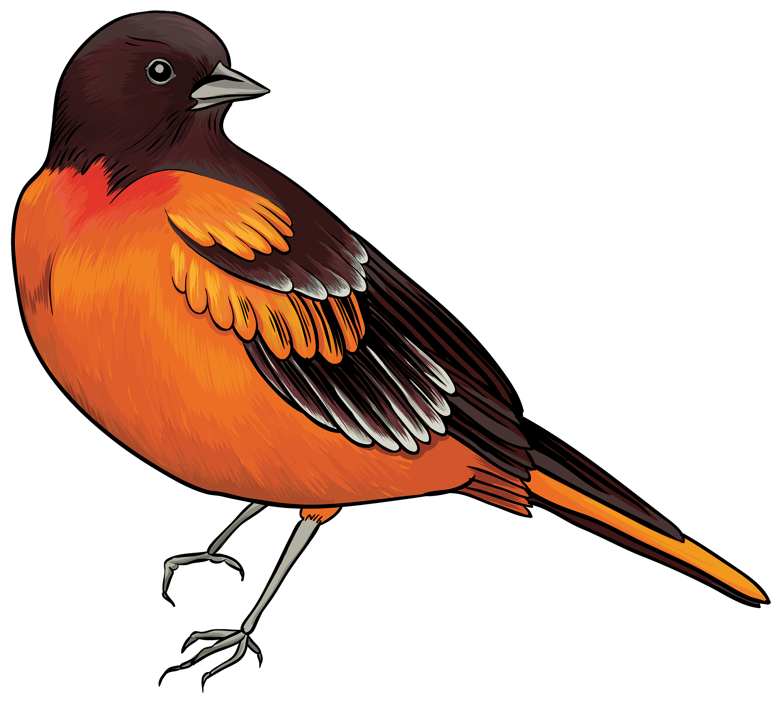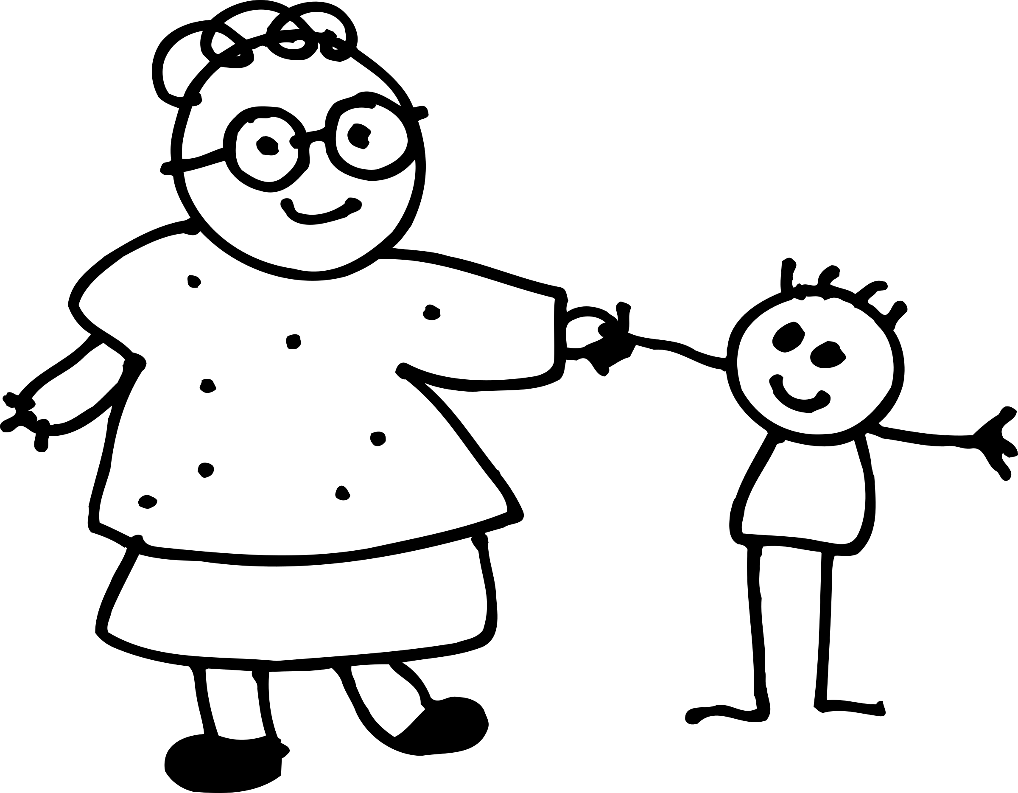 |  | Seasonal Changes: Describe 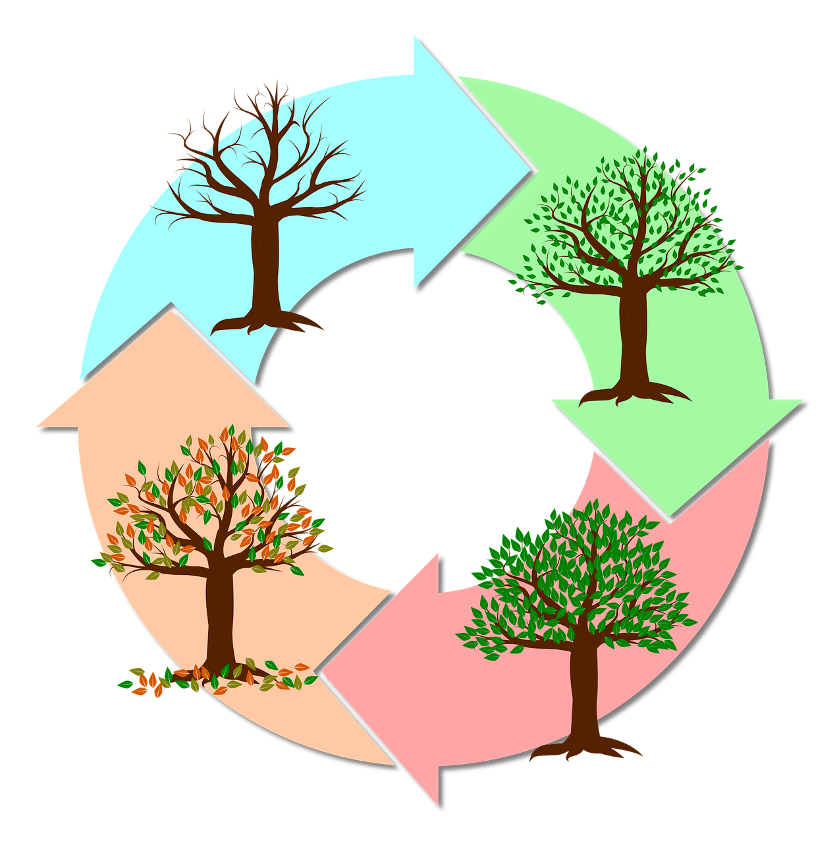 | Plants: Identification & Structure  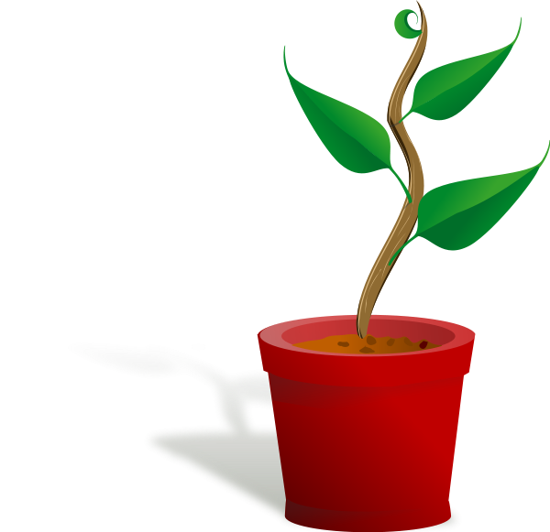
Year 2 | Uses of everyday materials:  Compare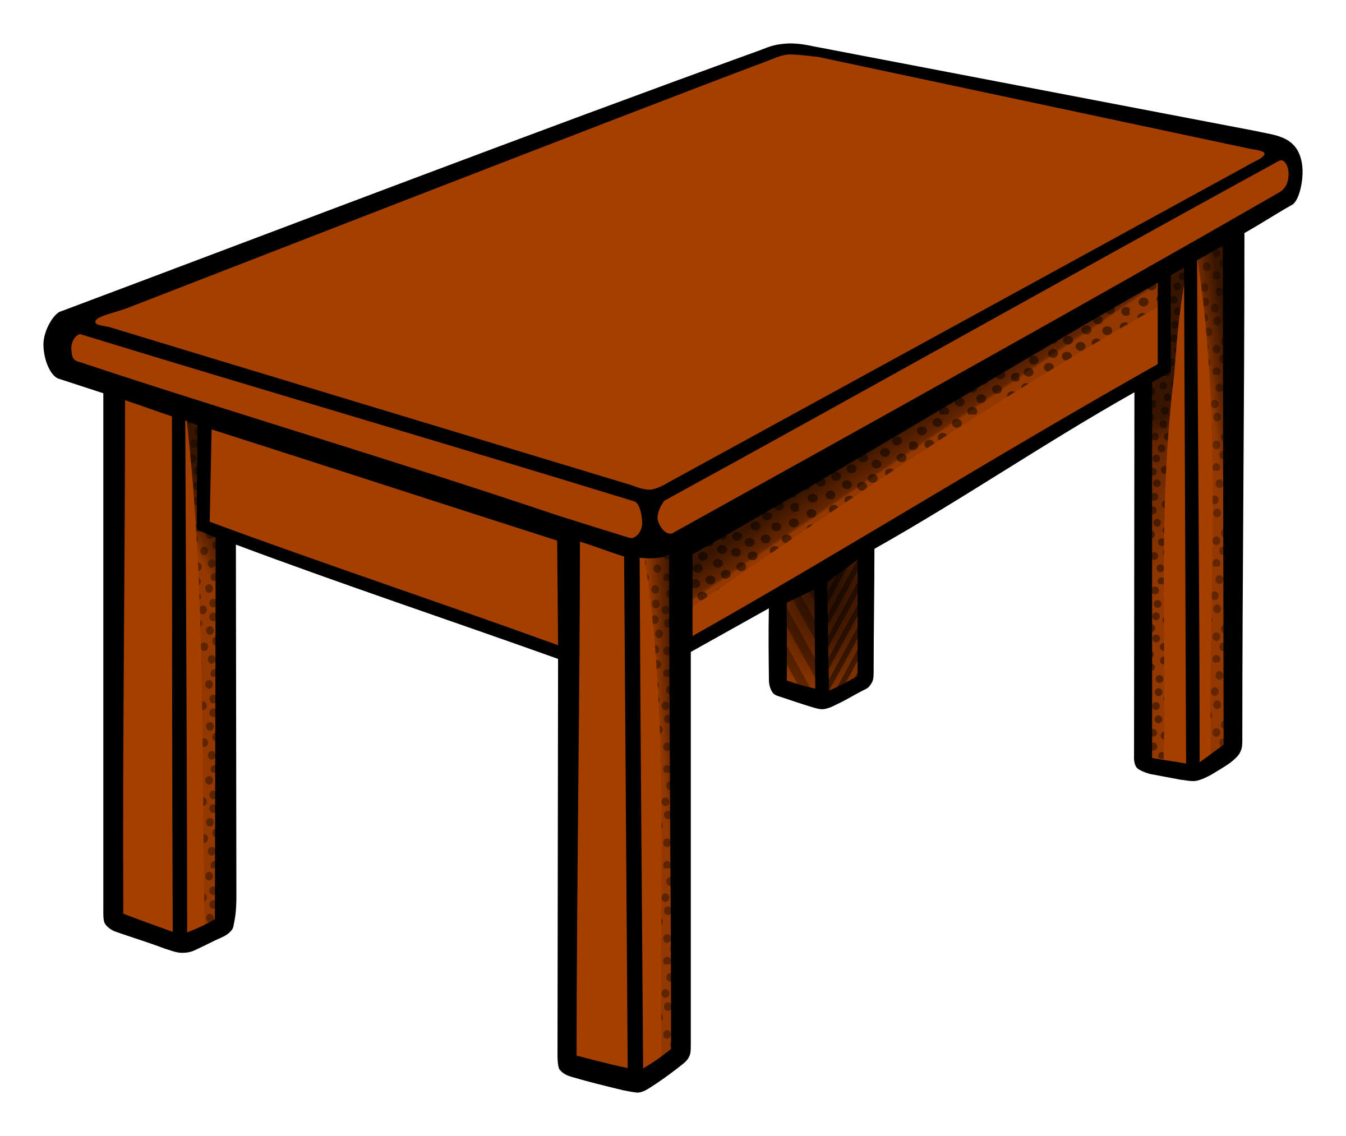 | Living things &habitats  Habitats around the world |  | Animals inc humans-  Growth  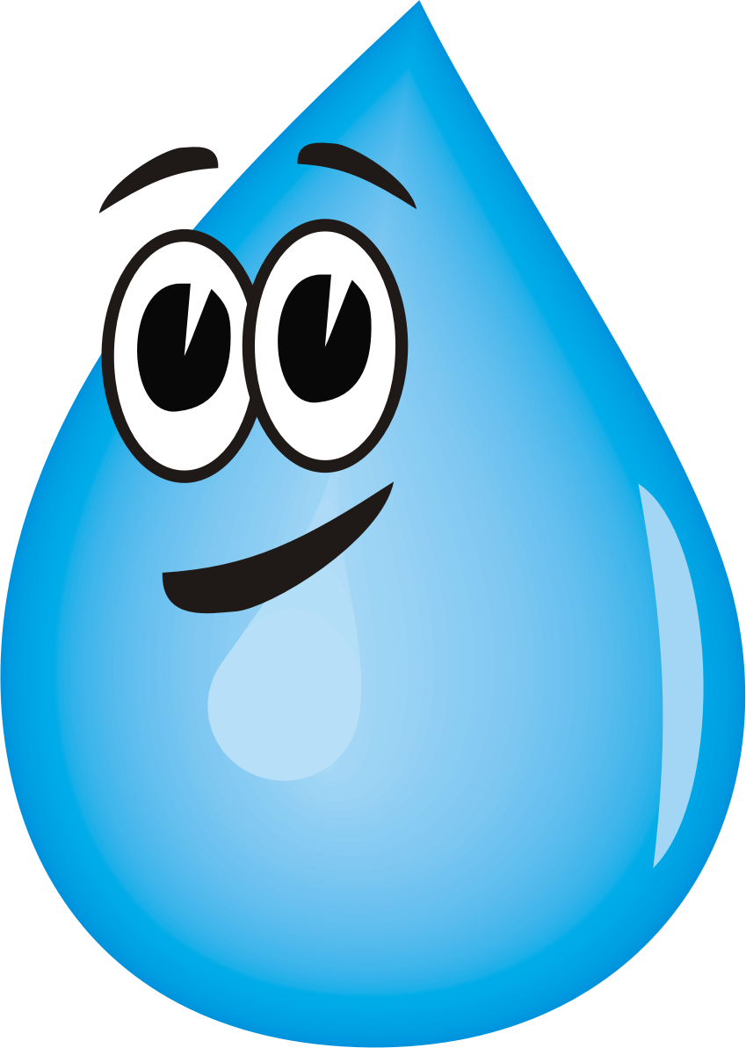 | Animals inc humans  Life cycles  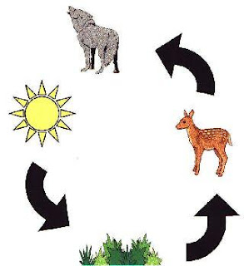 | Living things & habitats  Plant & animal identification & habitats 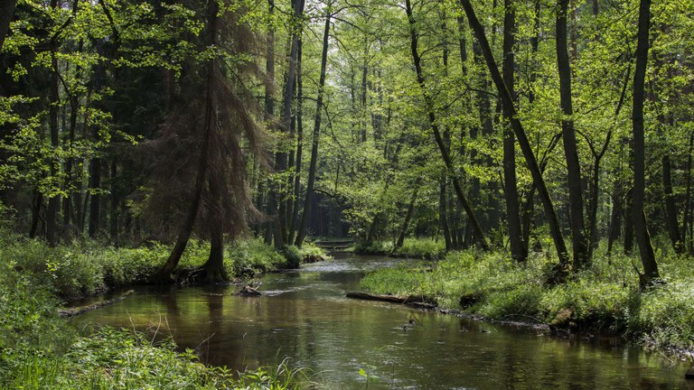 | Plants:  How they grow & what they need.
*National Curriculum knowledge and skills are stipulated per Year group
Key Stage 2

 | Material madness |  | Animal magic |  | Living planet
Year | Aut 1 | Aut 2 | Spring 1 | Spring 2 | Summer 1 | Summer 2
Year 3 | Rocks/Soils: Properties and comparisons  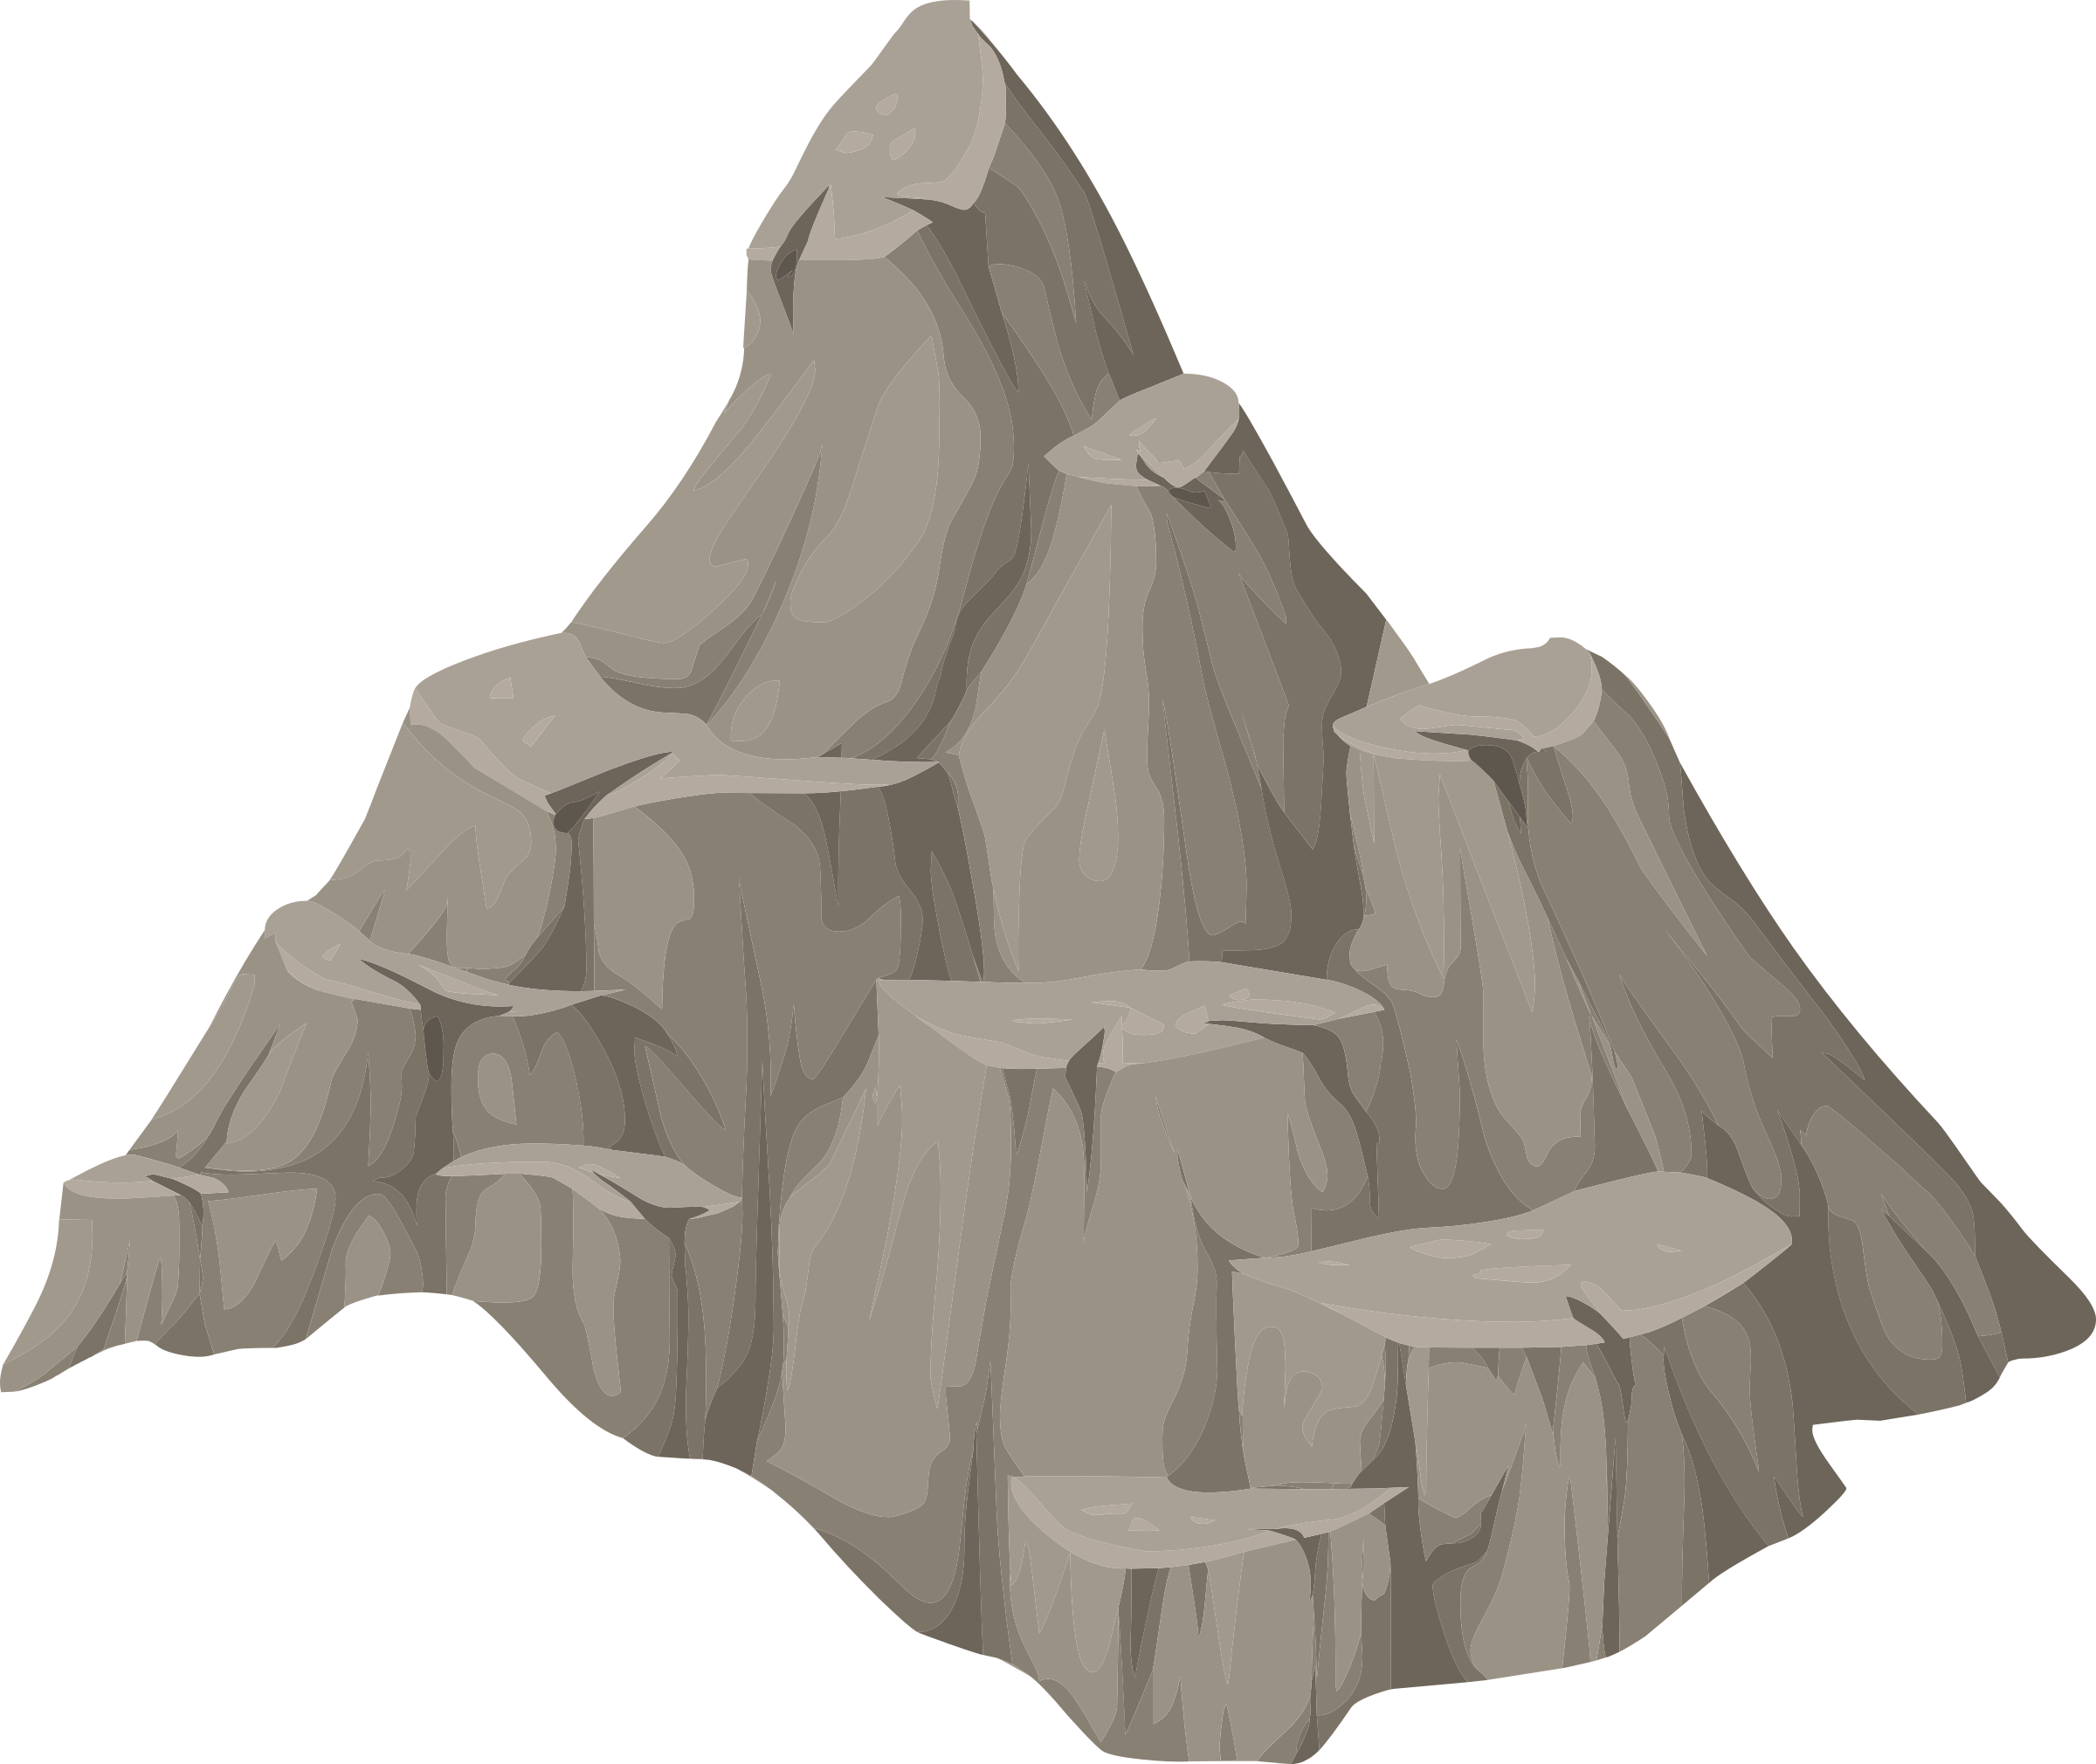 | Light: Shadows & reflection   | Animals including humans-  Healthy me, skeletons & movement  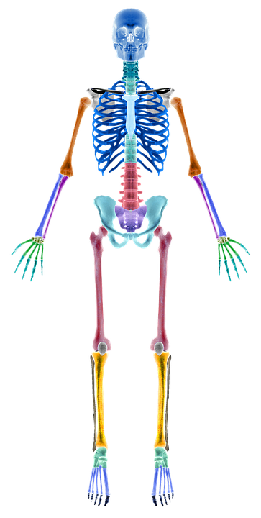 | Scientific enquiry  Humans exploring the magic of science. | Forces: Attract or repel?  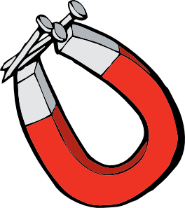 | Plants:  Functions
Year 4 | States of Matter: Solid, liquid or gas?   | Electricity: Circuits & conductors  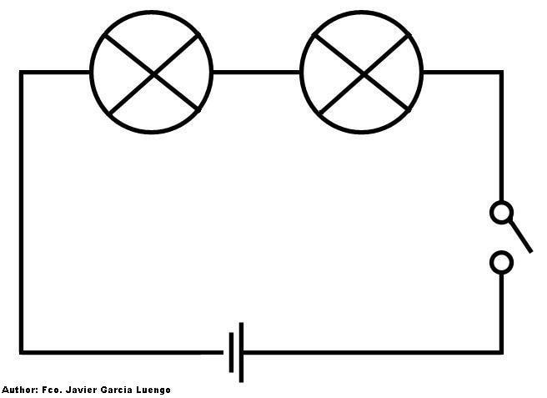  This Photo by Unknown Author is licensed under CC BY-NC-ND | Animals including humans-  Digestive system & Teeth  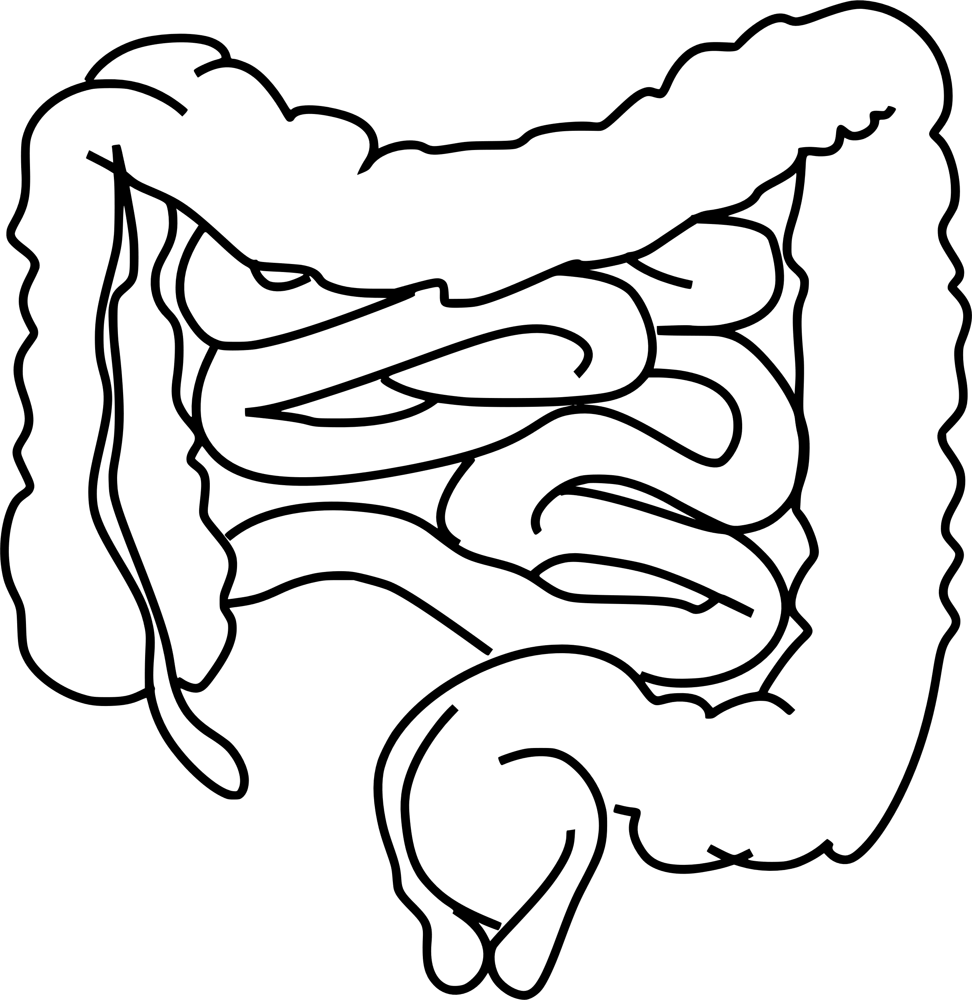 | Animals including humans –  Classification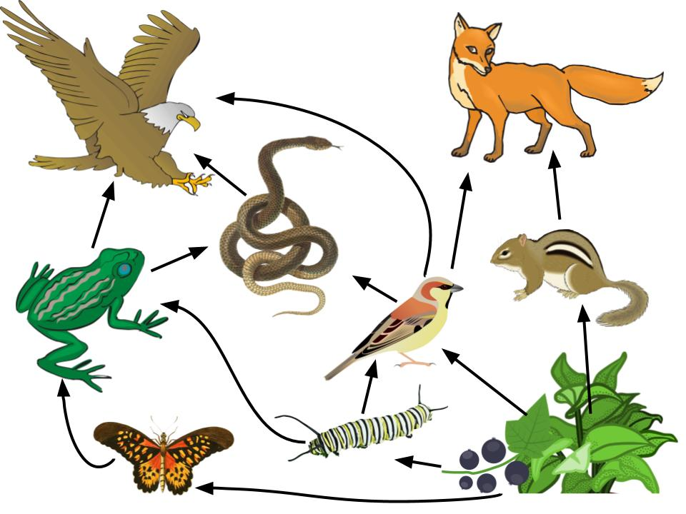  This Photo by Unknown Author is licensed under CC BY-SA-NC | Living things & habitats Classification and conservation | Sound: What is sound?  
Year 5 | Properties & changes of materials: Comparative testing  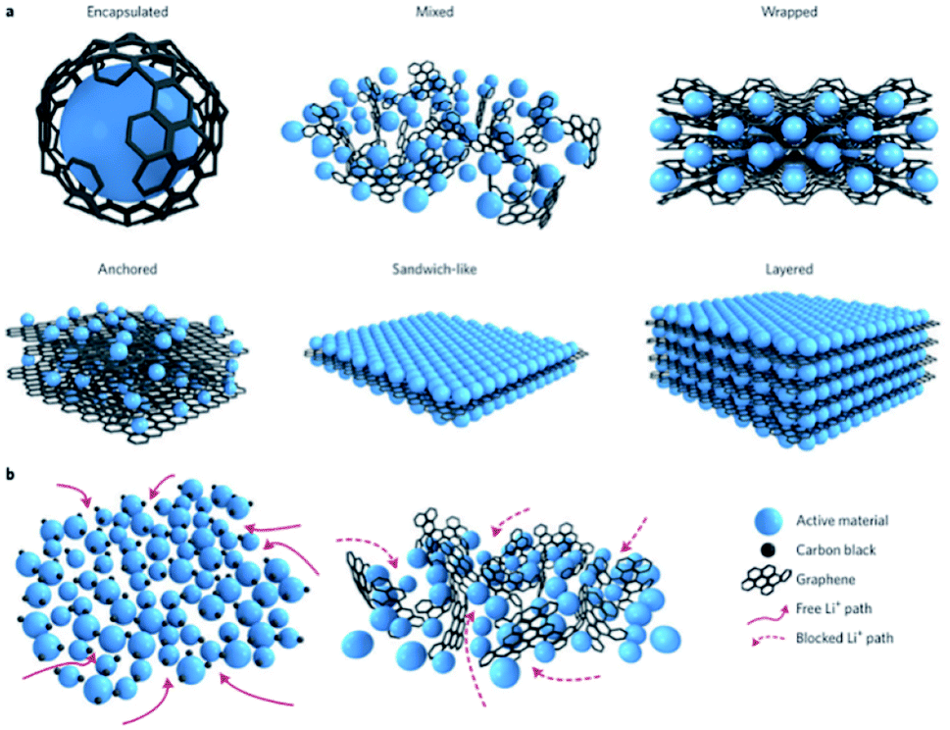  This Photo by Unknown Author is licensed under CC BY-NC |  | Animals inc humans –  Human development  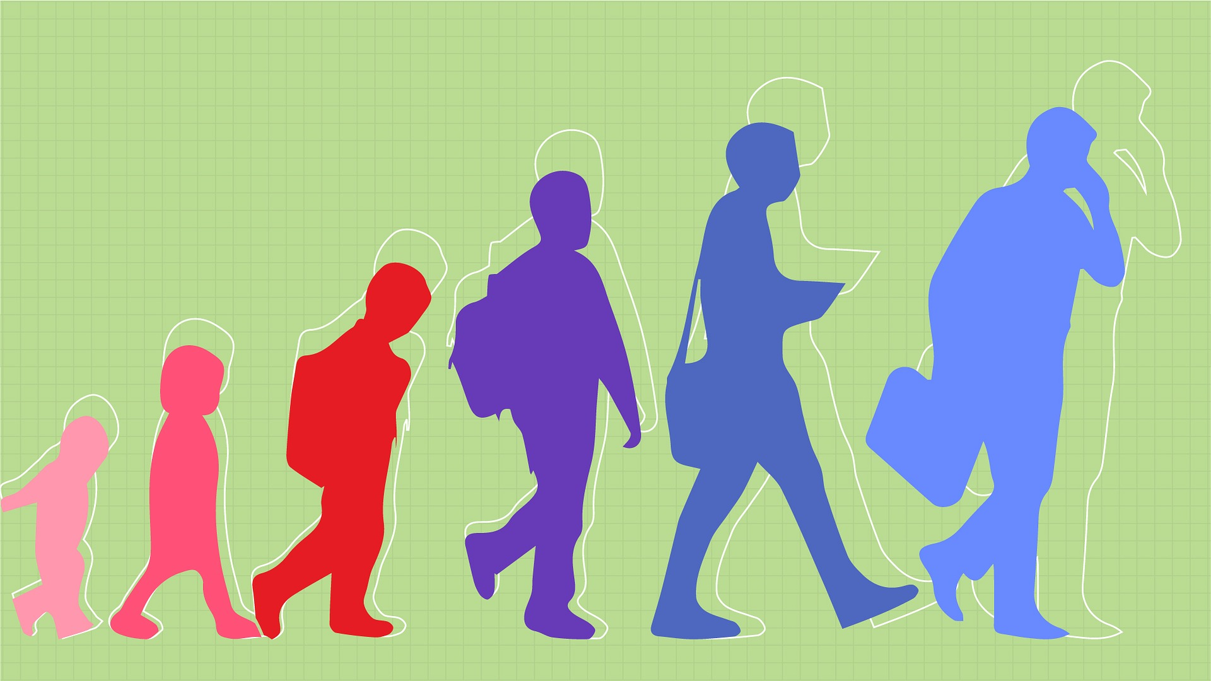  This Photo by Unknown Author is licensed under CC BY | Living things & habitats  Compare life cycles and reproduction in plants and animals | Forces: Resistance  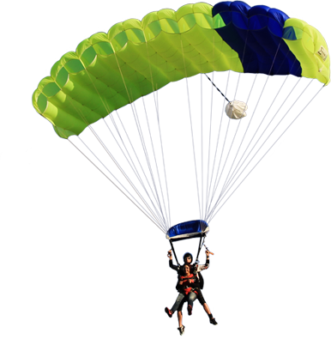 | Earth/Space:  Solar system  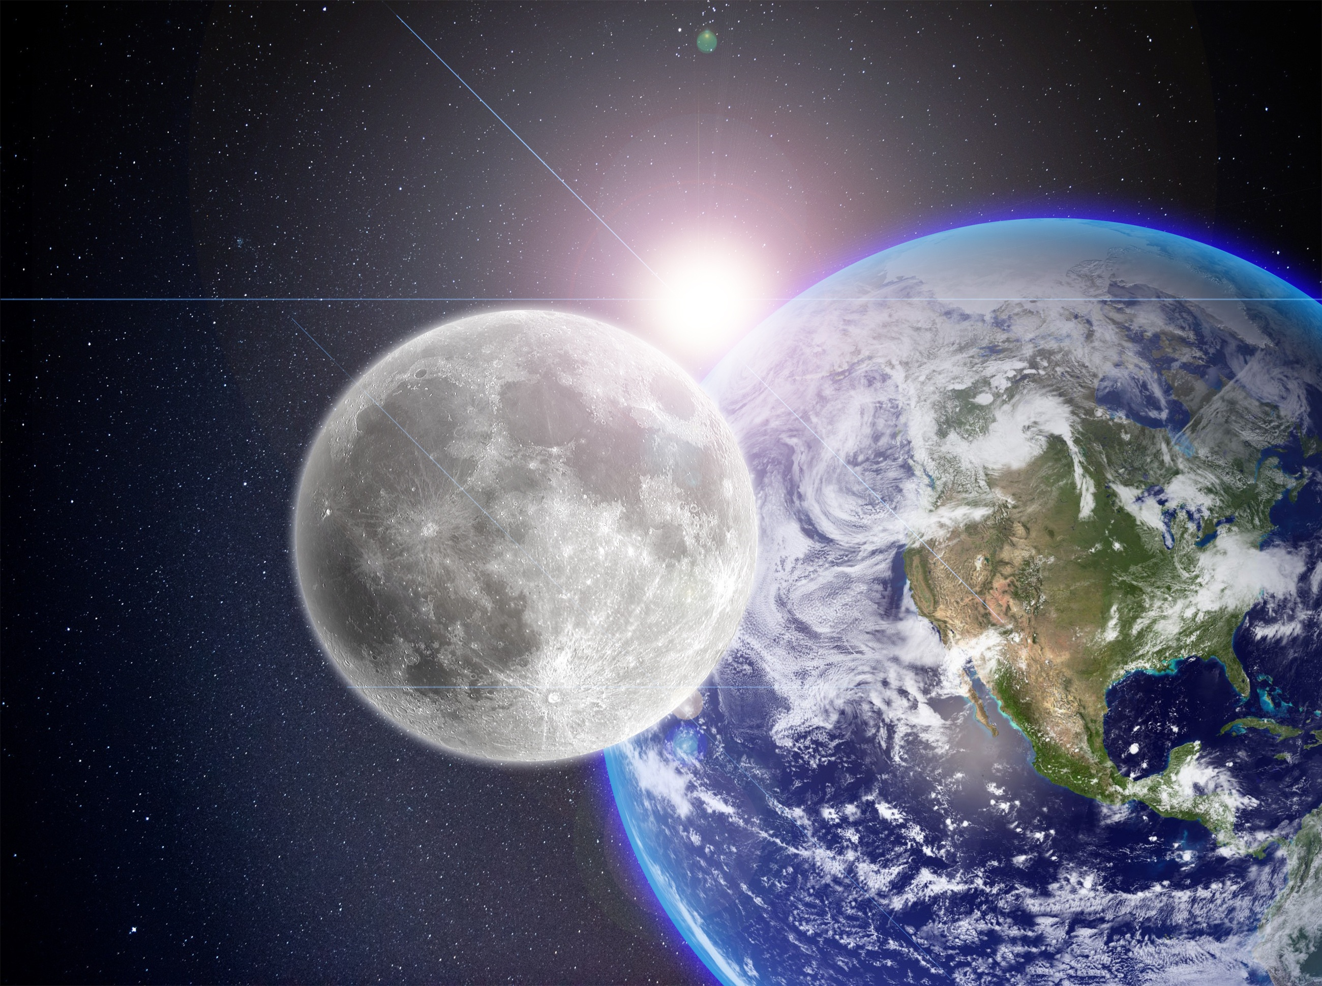
Year 6 | Electricity: Changing Circuits, voltage and symbols. | Light: How we see things  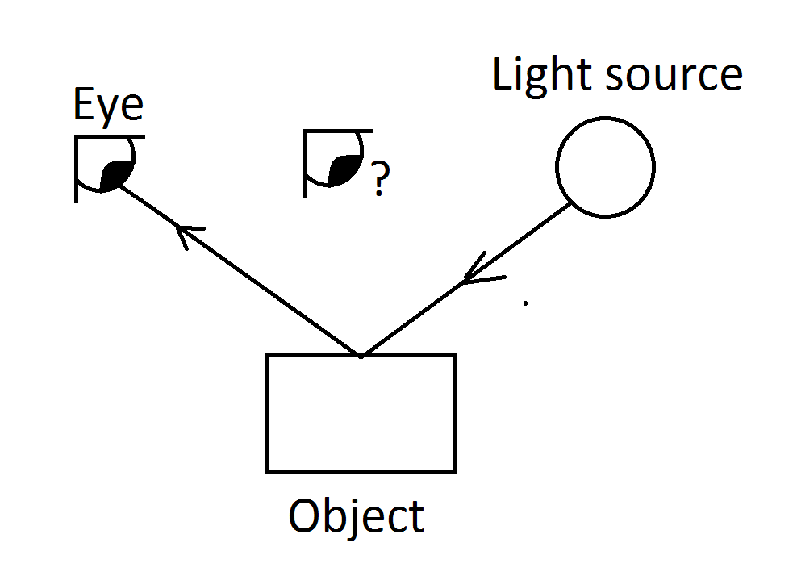 | Animals inc humans –  Circulatory system and lifestyles | Living things & habitats  Classification & characteristics | Evolution and Inheritance:  Change over time | Looking after our environment
*National Curriculum knowledge and skills are stipulated per Year group

