Pike Fold Primary School

End of Year Report
Name:

Year
1 Fold
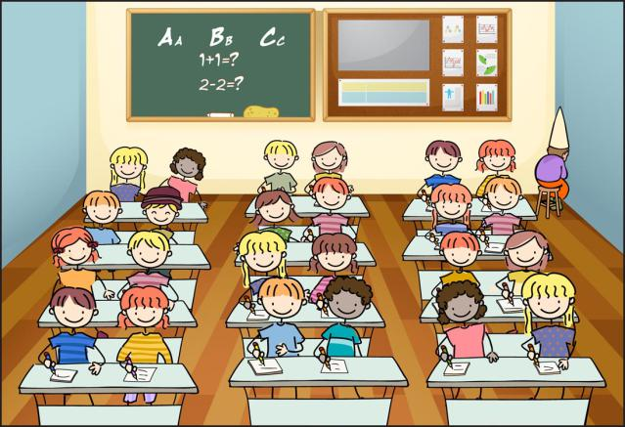
School year/class:

Other information:

 | Progress |  |  | Attainment |  |  | Effort
 | Below expected progress | Making expected progress | Above expected progress | Working towards the national standard | Working at the national standard | Working at greater depth than the national standard | Sometimes tries hard | Tries hard most of the time | Always tries hard
Reading
Comment:
Writing
Comment:
Grammar,
Punctuation
and Spelling
Comment:
Maths
Comment:
Science
Comment
Foundation Subjects | Progress |  |  | Effort |  |  | Comments
 | Below expected progress | Making expected progress | Above expected progress | Sometimes tries hard | Tries hard most of the time | Always tries hard
Computing
PE
Art
D&T
Music
RE
PHSCE
History
Geography
General Comments
Signed:
Class teacher
Signed
Headteacher
Date

