Friday 5th February 2016

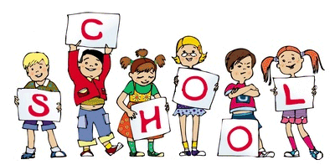

MCj04126840000[1]

MCj04126840000[1]

Staff

Miss Draycott – KS1 Manager – Assistant Head

1P – Miss Trotter, Mrs Dearden and Mrs Childs

1F – Miss Draycott and Miss Riggall

2P – Mrs MacKenzie, Mrs Thompson

2F – Miss Garner, Mrs Howarth

Homework Marks This Week

Spelling Test:

Homework Complete:

Homework this week.

Spellings – Week seven phase 5 to be tested on Thursday for Year 1. Year 2 spellings are sent home today to be tested on Monday.

Literacy – Comprehension books for year 2 and maths books due in on Tuesday.

Reading – Please make sure that your reading books are returned by Wednesday in order to be changed.

Websites – Check out our new website! Lots of resources and information!

**www.pikefold.manchester.sch.uk**

Welcome to the Key Stage One newsletter! Our parent workshop based on maths will be back again next Friday at 3.00pm. Cinema night is on Tuesday 9th February and costs £2.50 with a sandwich included! There will be two parent information workshops this coming week – Phonic Screening – 10th February at 3.00pm and Introduction to the KS1/Year 2 SATS test – 11th February at 3.00pm. KS1 SATs are on the week commencing the 23rd May, KS2 SATs are on the week commencing the 16th May and the Phonic Screening Check is the week commencing the 13th June. Please do not take holidays during the school terms.

General Reminders

* Please make sure that your child’s P.E kit is in school on a daily basis.
* I will be available to speak to every morning on the door and if you require more time an appointment can be made.
* Coffee morning every Friday after assembly where Lee Burns the Parent Governor will be available to speak with.
* Please label your child’s jumper with their name. If there is no name on a jumper it is almost impossible to find.
* KS1 SATs – 23rd May, KS2 SATs – 16th May and the Phonic Screening Test – 13th June
* Parent workshop – maths – every Friday at 3.00pm

Stars of the Week

This weeks stars are:





1P – Tumi

1F – Charley I

2P – Haseeb

2F - Lilly