Friday 18th September

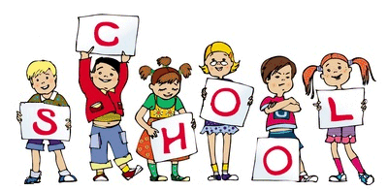

MCj04126840000[1]

MCj04126840000[1]

We hope you have all had a good first week in Reception and Nursery. The children have had a lovely time getting to know their new environment and making lots of new friends as well as building good relationships with their key workers. First we would like to thank you for your patience at home time. Our priority is that every child gets home safely and we are grateful for your understanding. This week we have been discussing our ‘High 5’ rules to follow when at school. When we see children doing these rules we give them a big ‘High 5’. The ‘high 5’ rules for your information are:

1. Share

2. Be Kind

3. Be helpful

4. Take Turns

5. Look after our toys and classroom

General Reminders

* Please make sure that your child’s P.E kit is in school on a daily basis. (Reception Only) PE is on a Monday and PE kits can stay in school for the whole half term.
* Please remember to bring in a waterproof coat and wellies (these can stay at school) everyday

At Home

Ideas to help at home –

Reception – This week’s homework is in your Homework folder it is to complete a sheet ‘All about me’ – Please bring back by Wednesday 23rd Sept

Please could you encourage your child to get dressed by themselves as this will help them when getting ready for PE.

Encourage your child to practise writing their name

Encourage your child to practise their scissor skills

Useful websites –

<http://www.abc.net.au/abcforkids/sites/playschool/>

Stars of the Week

This weeks Reception stars are:

**Miss Hawcroft – Harry B**

**Miss Whittle – Murishe**

**Mrs Hardy – Jayden N**

**Mrs Renshaw – Oscar**

This weeks Nursery stars are:

**Mrs Armstrong & Mrs Singh – Corey M**

**Mrs Gyves & Miss Casey – Leighton**

**Mrs Connell & Miss Armistead – Iyana**[](http://www.google.co.uk/url?sa=i&rct=j&q=&esrc=s&source=images&cd=&cad=rja&uact=8&ved=0CAcQjRxqFQoTCMvglZ6A-scCFYxuFAodGpgExw&url=http://www.star-network.org.uk/index.php/news/comments/finished_those_finals_welcome_to_star_graduates/&psig=AFQjCNFc3KXkv2GomG9IIPHesW7q7Kvwlg&ust=1442439519771587)

Notice Board

TOPIC – People who help us (Our 1st EYFS Assembly will be on Friday 16th Oct at 2:30pm it will be a Harvest Assembly no certificates will be given, You will receive a letter shortly with more information)

We will also be running some parent phonic sessions and maths sessions this half term, more details to follow.