Friday 1st December

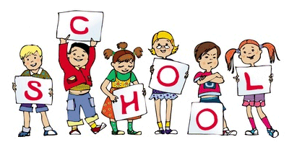

MCj04126840000[1]

MCj04126840000[1]

Wow! We have had a very busy week in school, this week. Nursery have been learning lots of songs for the celebration they are sharing with you next week. Reception have been learning their lines and songs for the snowman show they are sharing with you next week. Some of the children have really surprised us with how many words they can remember or how brilliant they are at singing.

Also, on Monday this week an Elf arrived and has been hiding in the classroom each day. The Elf is a good elf who is sharing a good deed with us and helping us to do good things each day. (Why not try this yourselves at home).

In math’s this week Nursery have been finding as many combinations as possible of moving 4 objects.

In math’s this week Reception have been sharing fish equally between 3 hungry animals. They have been brilliant!

We can’t wait to see you all on Tuesday & Wednesday at our Christmas Shows.

Notice Board/Dates for your Diary

TOPIC – **Christmas Stories**

**Dates for Diaries:**

**Tuesday 5th December Reception** Nativity (Please arrive at school at 2:00pm for a 2:15pm start)

*If we finish before 3:15pm you will be able to take your children straight home.

**Wednesday 6th December Nursery** Christmas Sing a long (Please arrive at school at 2:15pm for a 2:30pm start)

Due to fire regulations unfortunately only **2 adults per child** will be allowed to watch the performance. Some of our super year 6 children will meet you at the community entrance to collect a £1 donation (per person) and show you into the hall.

Great News for Forest School!

'Thanks for everyone who voted for us in the Tesco's Bags of Help community grants scheme. We are delighted to announce we have bagged £4,000 for our Forest School.

Work will now begin on bringing the project to life which, will include an expansion of the current forest school site to benefit more children at Pike Fold'.

Mrs Armstrong

(Forest School Practitioner)

At Home

Ideas to help at home –

Practise Gross motor skills, e.g. using the climbing frame at a local park or riding on a bike or scooter, holding chalk or pens to draw on the ground/large paper.

Reception – Continue to work through your home learning packs and practise reading, writing, drawing and counting.

General Reminders

* Lots of children have been taking school resources home this week. Please talk to your children about this and make sure you return the resources back to school.
* Please talk to your child about ‘respectful’ behaviour towards school resources (we have lots of things broken).